March Round Assumptions
The March 2025 Round of the QMFM model follows the November 2024 round.
ASSUMPTIONS
External Environment Assumptions:
- Rwanda’s trading partners' demand is projected to grow at 4% p.a. for the 2024-28, close to the trend of the last 7 years.
- In addition, trading partners’ inflation is projected to ease from 2.3% to 1.73% p.a. for the 2024-28 period, close to the trend of the last 7 years as well.
- This assumption is irrespective of recent developments in global conditions, especially trade tensions, since the implication is still unclear.

Fiscal Assumptions:
- The fiscal assumptions are set for the fiscal years 2025/26 and 2026/27 and the last two quarters of 2024/25 (i.e., Q3 and Q4 of 2024/25) based on current fiscal targets.
- Revenues
  - New tax measures are expected to increase government revenues over the medium term (2025/26, 65.4B increase due to tax measures).
    - 2025/26: Increase in taxes by 0.1% FRW 65.4 billion (from March fiscal revision).
- For the fiscal year 2025/26, the average revenue ratio is tuned to increase from 18.5% in 2025Q3 to 19.1% in 2026Q2. This increase is expected to be a result of new tax measures are expected to increase government revenues over the medium term (2025/26, 65.4B increase due to tax measures).

Monetary Assumptions:
- Exchange Rate Tuning:
- The exchange rate is hard-tuned (i.e., explicitly fixed or set) for the first quarter (Q1) of 2025.
- The first two months of Q1 (January and February 2025) are based on observed data, while the unobserved month of March 2025 is estimated using the hard-tuning approach to ensure consistency with the observed trends.
- Exchange Rate Depreciation:
- A soft-tune (i.e., a flexible or adjustable assumption) is applied to the exchange rate depreciation rate for Q2 of 2025.
- The annual depreciation rate for the exchange rate in 2025 (January-to-December) is assumed to be 8%. Of this total depreciation, 2.8% is assumed to occur in Q1 of 2025. The remaining 5.2% depreciation is distributed evenly across Q2, Q3, and Q4 of 2025, implying a depreciation of approximately 1.73% per quarter for these periods.
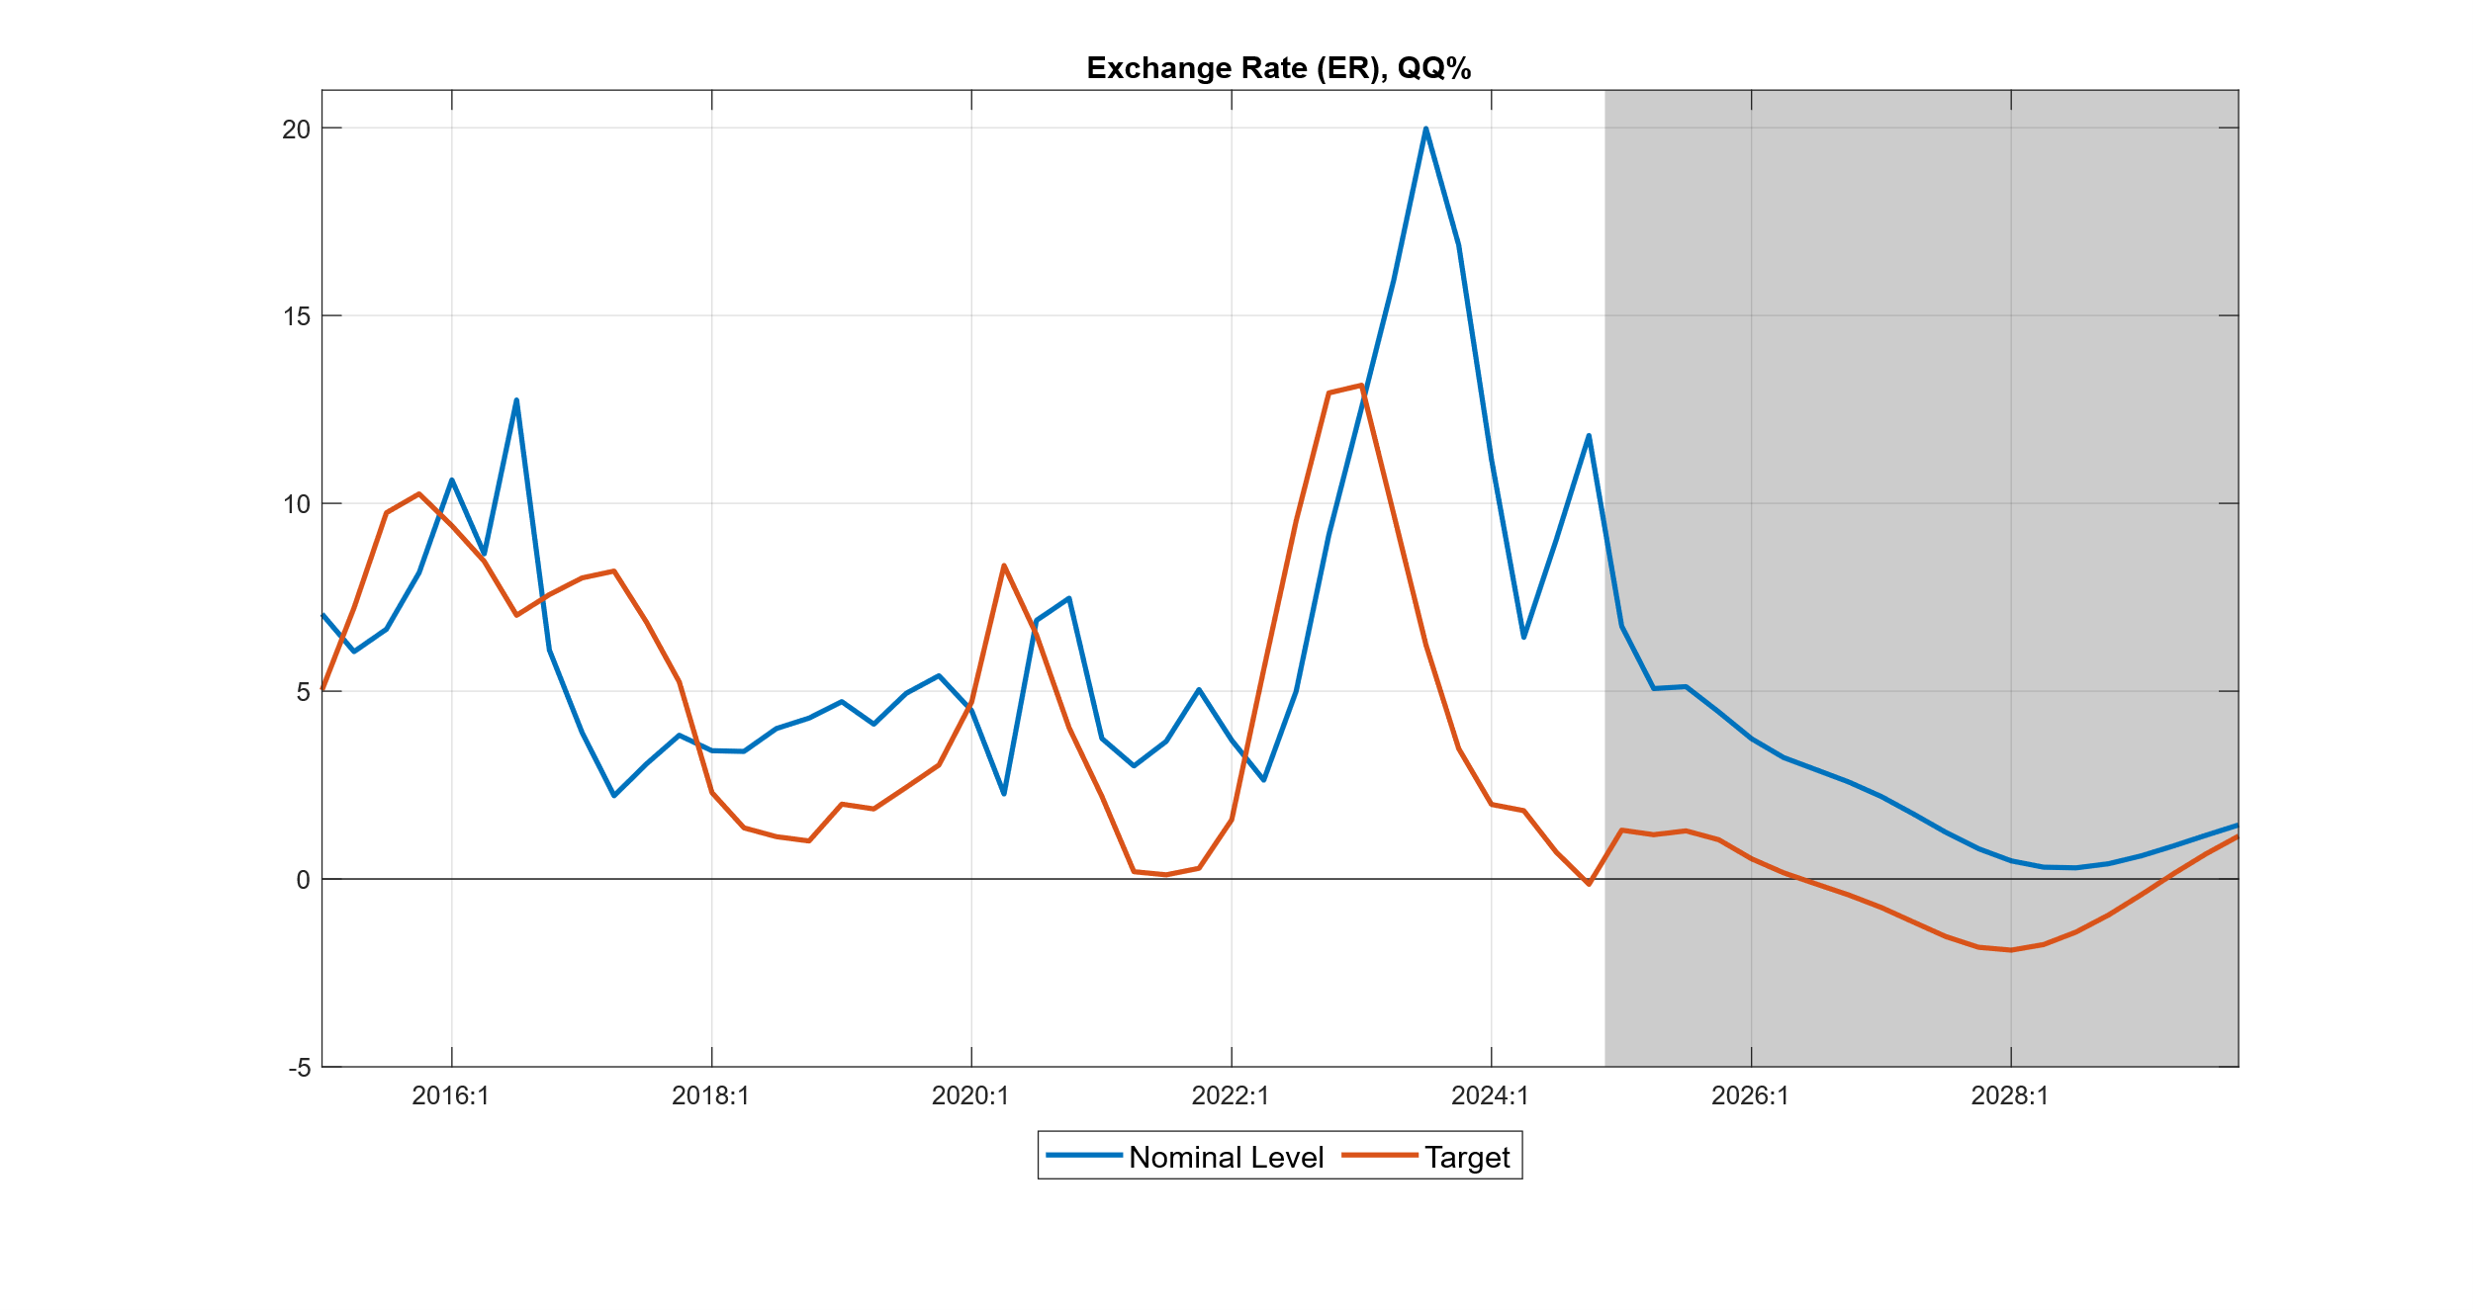
OUTLOOK
Demand
The output is expected to remain strong in the medium term with an average growth rate of 7.5%. This is driven primarily by government demand and, secondly, private consumption, whose growths are 10.8% and 7.2%, respectively. The 2026 growth is expected to be adversely affected due to the slowdown in those components, coupled with a shrinkage in investment despite steady export growth and a significant slowdown in import growth, which are likely to ease current account balance pressures.
Figure 1: GDP Growth and Components
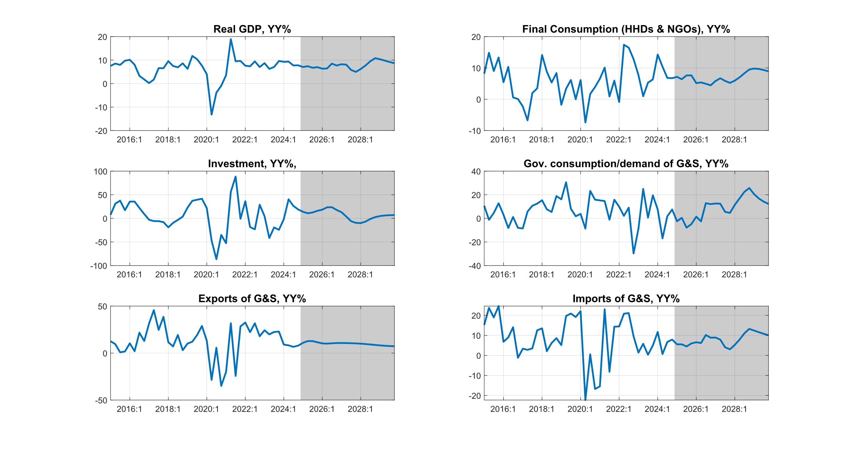

Inflation
Inflation is expected to converge to a 5% medium-term target. A tighter monetary policy is expected to affect inflationary levels. The outlook after 2026 and 2027 is that lower levels of inflation will be experienced due to a slowdown in growth after a stimulant episode from Bugesera and RwandAir injections. Nonetheless, inflation will converge back to the medium-term target of 5% after an increase in consumption (both Public and Private).

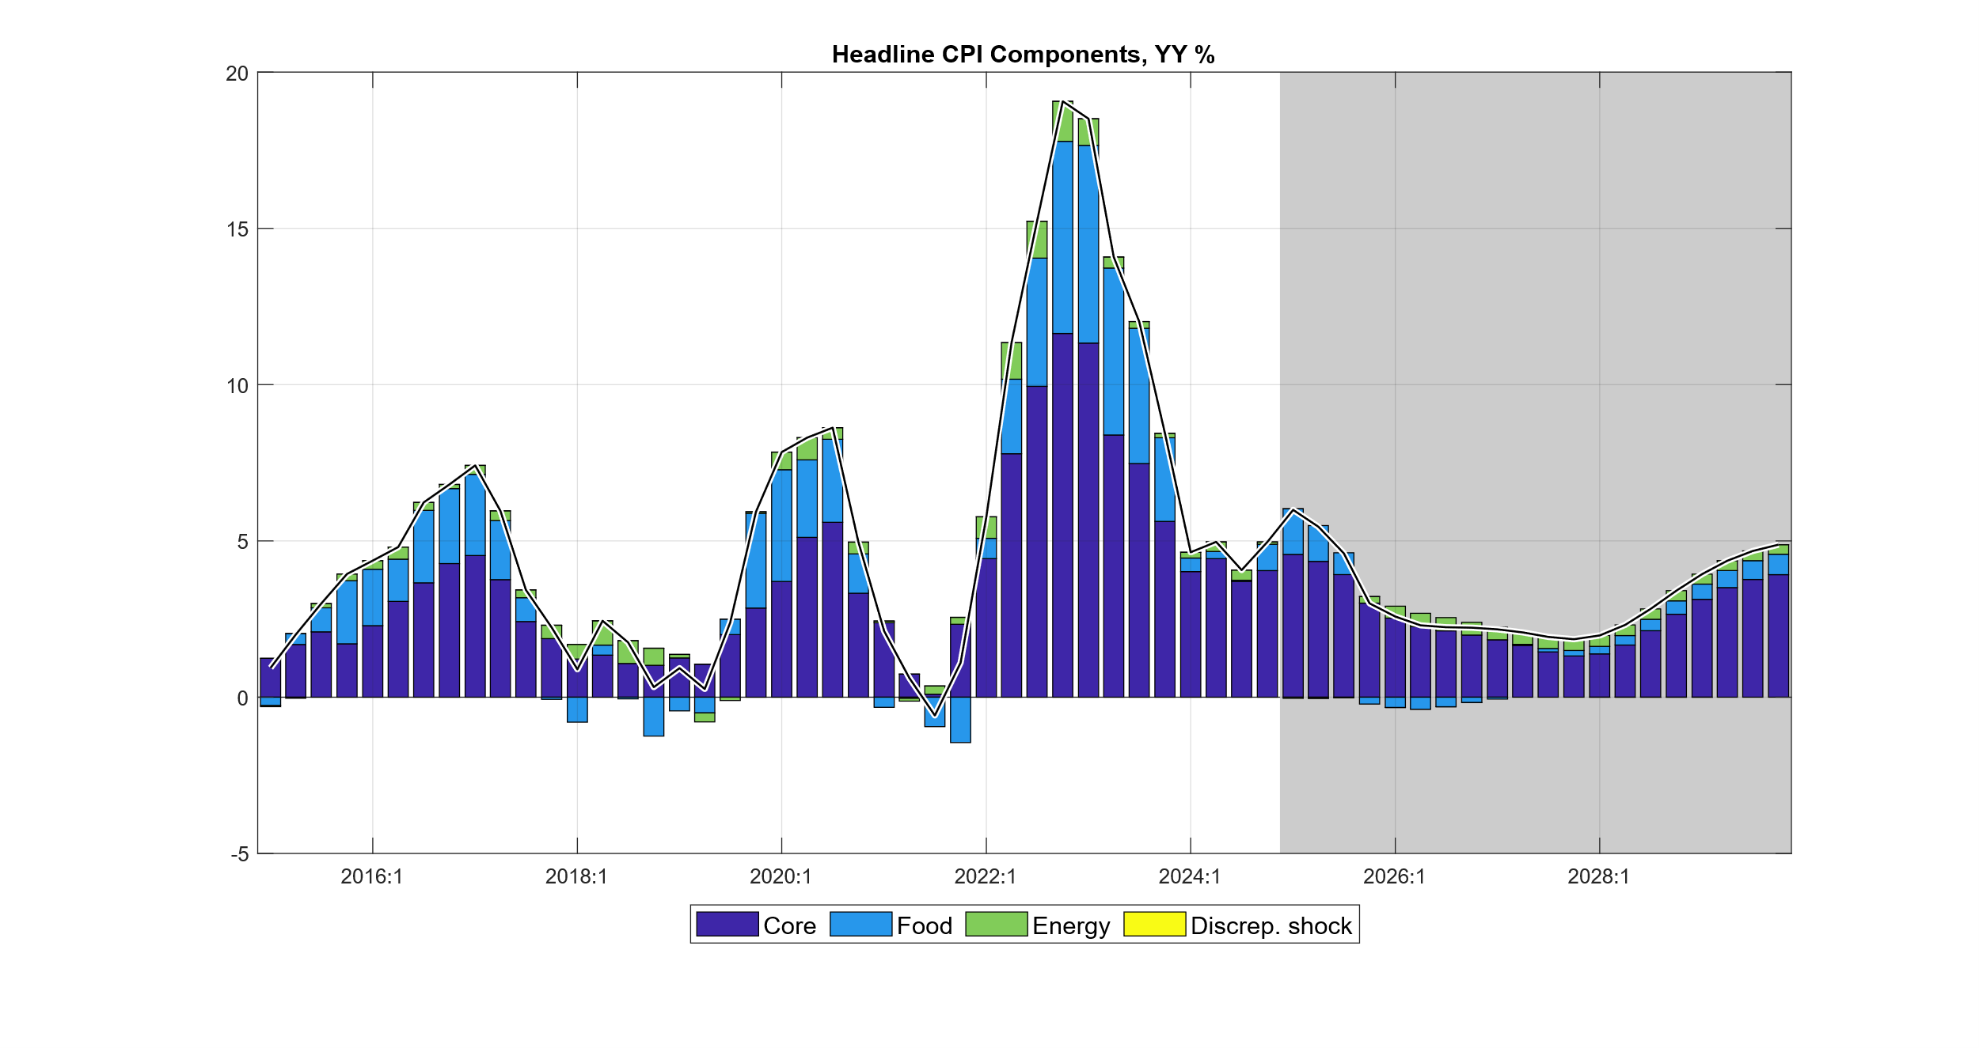

Deficit
In the future, the government is expected to realize some consolidation from 2025 through 2027 relative to previous years. The expected contraction in government demand is 1.4% from 2024 to 2025, 0.145% in 2026, and 0.38% in 2027, as the deficit is targeted to reach 7.8% of the GDP at the end of this period.

Government Demand
GDem in 2025/26 Semester 1 shall increase by 7% from 23.1% to 30.1%. The government spending is expected to be slightly up despite Bugesera airport and RwandAir. This is mainly due to different substitutive measures like the retirement of subsidies for RwandAir that will be phased out, and other projects' reprioritization to accommodate the implementation of the two projects. …

Government Revenue
Government revenues are expected to follow a smoother path with an increasing trend. This trend is expected to improve in the medium term to an average of 19.8% from 2025 to 2029. This trajectory will result from the increase in tax collection, as well as the implementation of both compensatory and administrative tax measures.
Year 2029 is projected to yield the highest tax revenues after fully implementing all tax measures defined above with an average .

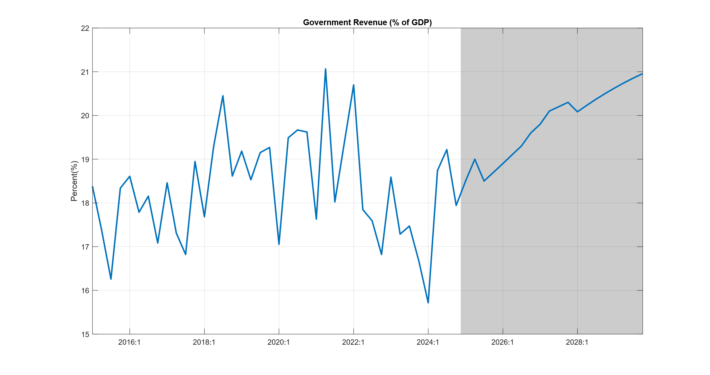
Government Demand
For the government to accommodate the strategic projects of Bugesera Airport and RwandAir, some projects for the budget were postponed for the year in which Bugesera Airport is expected to be implemented. Consequently, the government demand is expected to be affected downward. The projections show that the demand will decline by 3% in 2025/26; this leaves room for implementing the projects, and in the following years will grow positively.
This, of course, will also have an implication on the ratio-to-GDP of the demand, because in 2025/26 (2026) the government demand for goods and services will shrink to 20.25% (20.7%) from 22.3% (21.0%) in 2024/25 (2025), later on it picks up from 2028 and onward. These adjustments also confirm that, despite the adoption of strategic projects, it does not hamper the existing efforts of the government's consolidation.

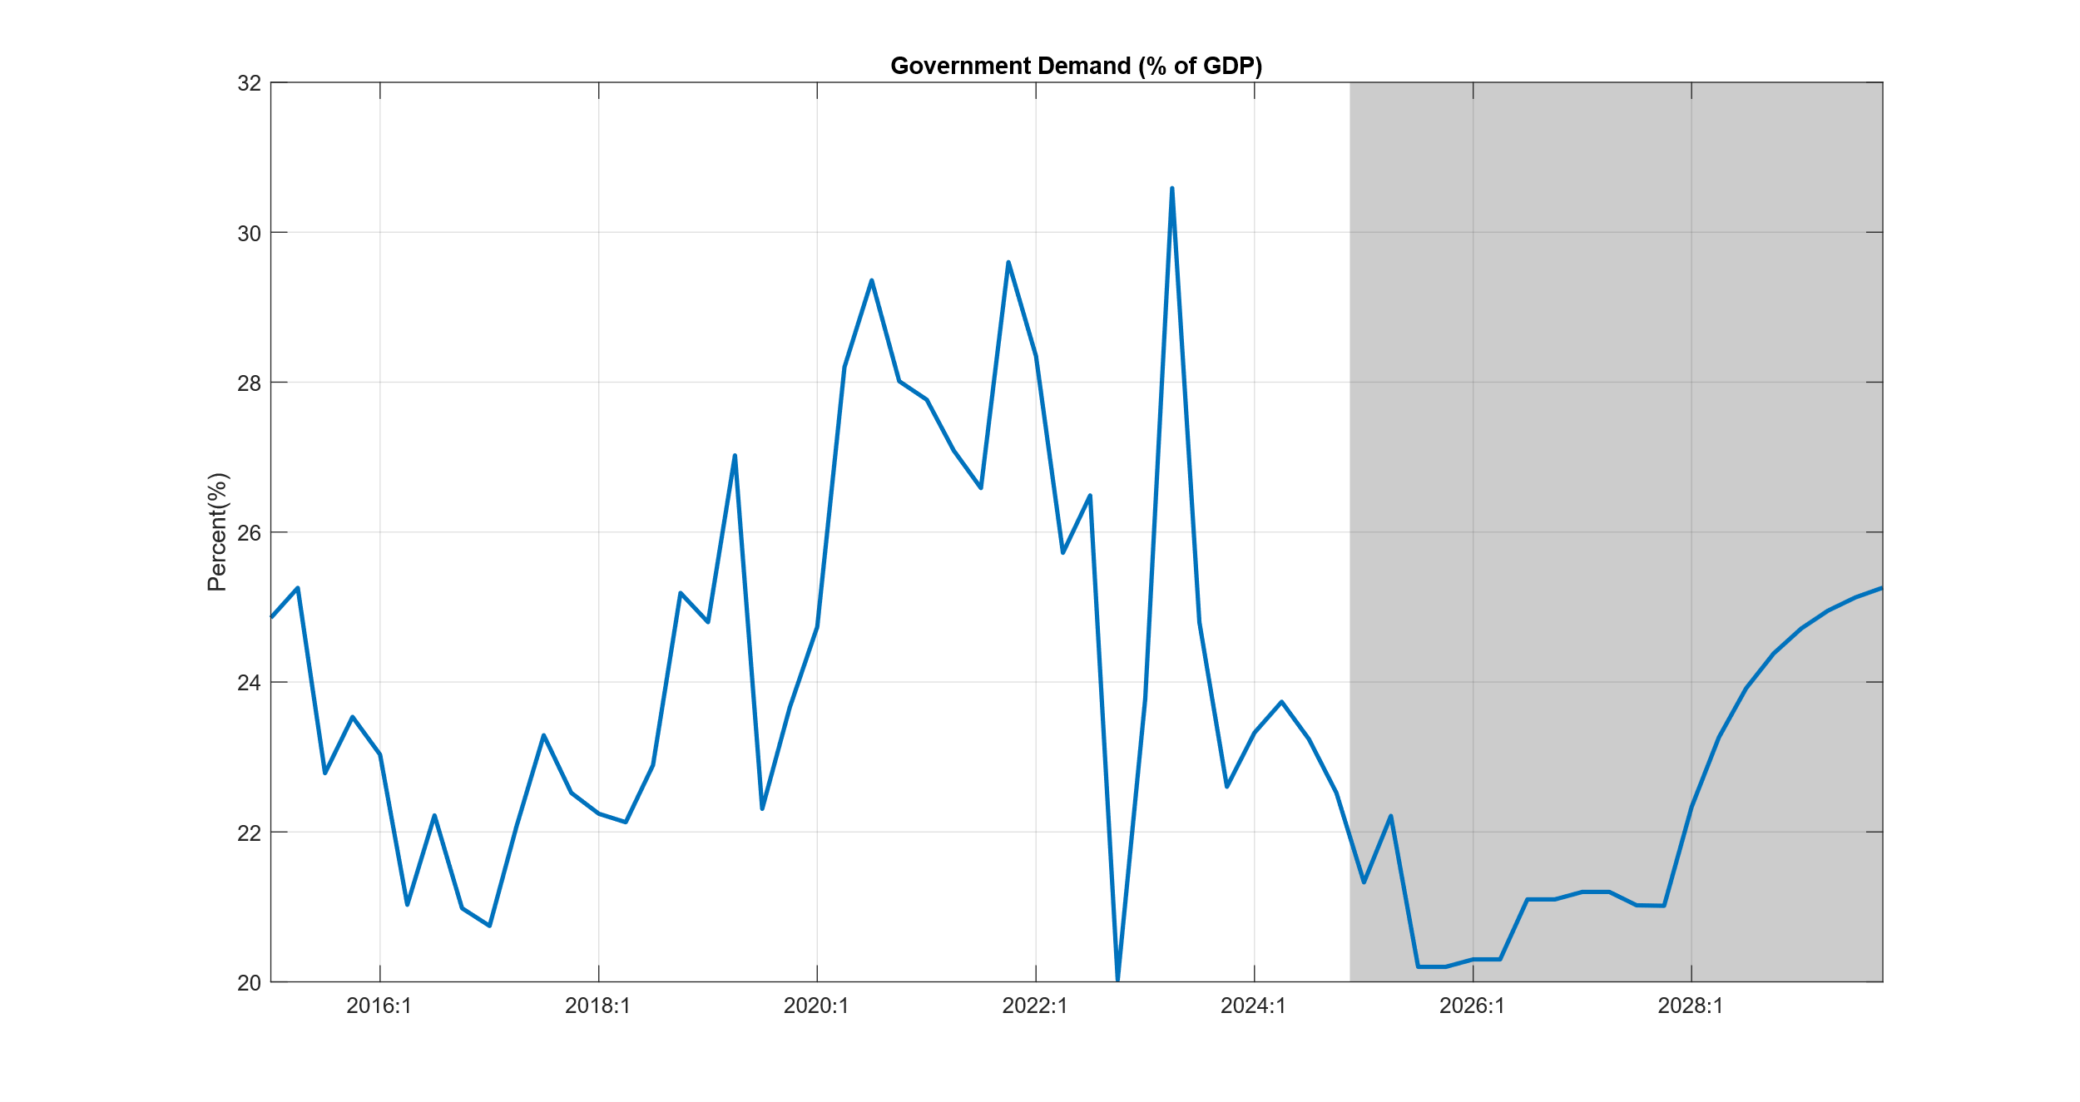

Other Spending
Moreover, other government expenditure will be adjusted. Notable change is observed in 2025/26, Semester 1, where it is expected to increase by 7.5% compared to the previous semester. This rise comes from 4.6% to 12.5% as a percentage of GDP. Other expenditures are aimed at approximately and around 5.5% in the medium term.
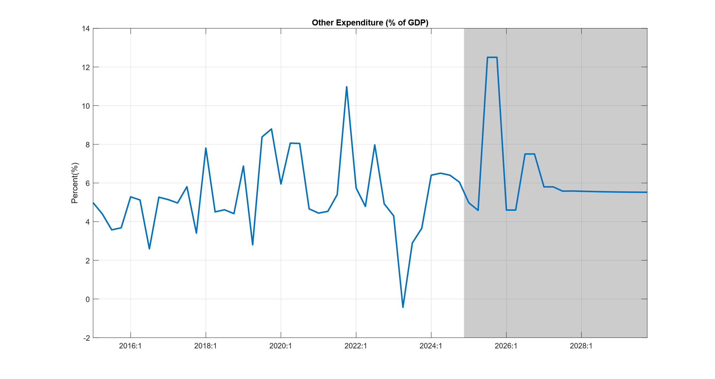

Deficit
The deficit (including grants) is expected to converge to its sustainable level of 7.5%. However, prior to this convergence, the deficit is expected to face a bump as other expenditures are anticipated to increase due to investments in equities for Bugesera Airport, specifically in 2025/26 and 2026/27 by 8.5% and 6.65%, respectively.
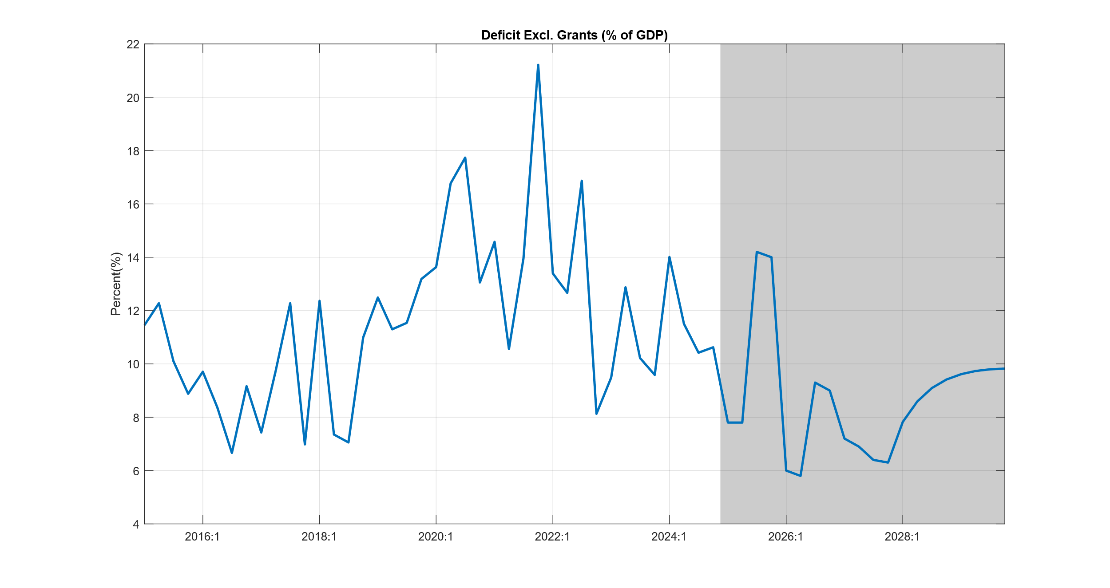

 | 2024Q1 | 2024Q2 | 2024Q3 | 2024Q4 | 2025Q1 | 2025Q2 | 2025Q3 | 2025Q4 | 2026Q1 | 2026Q2 | 2026Q3 | 2026Q4 | 2027Q1 | 2027Q2 | 2027Q3 | 2027Q4
CPI, y-on-y change | 4.74 | 5.09 | 4.15 | 5.09 | 6.17 | 5.60 | 4.71 | 3.04 | 2.61 | 2.32 | 2.26 | 2.24 | 2.19 | 2.09 | 1.94 | 1.87
GDP, y-on-y change | 9.72 | 9.82 | 8.03 | 8.10 | 7.30 | 7.70 | 6.96 | 7.25 | 6.55 | 6.66 | 8.87 | 8.00 | 8.60 | 8.39 | 5.99 | 5.12
Interbank rate, pct | 7.96 | 7.97 | 7.01 | 6.56 | 6.58 | 6.58 | 6.53 | 6.51 | 6.43 | 6.30 | 6.20 | 6.08 | 5.99 | 5.94 | 5.97 | 6.09
Exchange rate, y-on-y change | 17.34 | 14.58 | 11.49 | 10.09 | 8.87 | 8.50 | 7.45 | 5.49 | 4.70 | 4.22 | 3.65 | 3.16 | 2.77 | 2.38 | 1.96 | 1.50
Deficit, % of GDP | 14.01 | 11.50 | 10.42 | 10.62 | 7.80 | 7.80 | 14.20 | 14.00 | 6.00 | 5.80 | 9.30 | 9.00 | 7.20 | 6.90 | 6.40 | 6.30
Govt revenue, % of GDP | 15.72 | 18.74 | 19.22 | 17.94 | 18.50 | 19.00 | 18.50 | 18.70 | 18.90 | 19.10 | 19.30 | 19.60 | 19.80 | 20.10 | 20.20 | 20.30
Govt demand G&S % of GDP | 23.32 | 23.74 | 23.24 | 22.52 | 21.33 | 22.21 | 20.20 | 20.20 | 20.30 | 20.30 | 21.10 | 21.10 | 21.20 | 21.20 | 21.02 | 21.02
Other spending, % of GDP | 6.40 | 6.51 | 6.40 | 6.04 | 4.97 | 4.59 | 12.50 | 12.50 | 4.60 | 4.60 | 7.50 | 7.50 | 5.80 | 5.80 | 5.58 | 5.59

 | 2024Q1 | 2024Q2 | 2024Q3 | 2024Q4 | 2025Q1 | 2025Q2 | 2025Q3 | 2025Q4 | 2026Q1 | 2026Q2 | 2026Q3 | 2026Q4 | 2027Q1 | 2027Q2 | 2027Q3 | 2027Q4
GDP, y-on-y change in % | 9.72 | 9.82 | 8.03 | 8.10 | 7.30 | 7.70 | 6.96 | 7.25 | 6.55 | 6.66 | 8.87 | 8.00 | 8.60 | 8.39 | 5.99 | 5.12
Consumption, y-on-y change | 15.34 | 10.97 | 7.06 | 6.96 | 7.42 | 6.61 | 7.91 | 7.92 | 5.29 | 5.52 | 5.06 | 4.55 | 6.00 | 6.94 | 6.03 | 5.37
Investment, y-on-y change | -1.81 | 49.70 | 30.13 | 20.72 | 14.70 | 11.33 | 13.19 | 17.29 | 20.24 | 26.21 | 26.64 | 19.33 | 13.77 | 3.88 | -5.91 | -9.15
Gov. dem., y-on-y change | 7.83 | -15.62 | 1.74 | 7.76 | -2.44 | 0.39 | -7.58 | -4.74 | 1.41 | -2.53 | 13.72 | 12.81 | 13.41 | 13.20 | 5.60 | 4.69
Export, y-on-y change | 9.50 | 8.58 | 6.87 | 8.27 | 11.59 | 13.63 | 13.63 | 12.18 | 10.85 | 10.59 | 10.99 | 11.27 | 11.32 | 11.24 | 11.09 | 10.87
Import, y-on-y change | 12.43 | 0.65 | 6.93 | 8.23 | 5.68 | 5.69 | 4.58 | 6.16 | 6.79 | 6.39 | 10.73 | 9.23 | 9.33 | 8.19 | 4.13 | 3.08

This is also expected to negatively affect import components that contribute to demand boost like construction.

